Marketplace Builder Hackathon :

Day 1 Laying The Foundation For Your Marketplace Journey :

Step 1 : Develop a general E-Commerce web platform for electronics.

Step 2 : What problem does the marketplace solve:
1 - Time-Efficient : Provides same-day delivery options for select products.
2 - Convenience : Allows users to shop for electronics online,eliminating the need to visit physical stores.
3 - Custom-Friendly : Ensures harsle free returns and warranty services for damaged or faculty products.
4 -Cost Saving : Discounts and free delivery offers on products .

Step 3 : Business Goal:

Problem: Customers need reliable,affordable, and high-quality electronic products.
Products/Service:Mobile accessories,Laptops,Computers and other related electronics items.
Target Audience: Young,Adults and Professional workers age between (15 -49) years.
Business Outcome: Build long-term customer trust,increase sales and create a sustainable and stable buusiness model.
Data Schema:
Products :
- Product ID
- Product Name
- Product Category
- Product Description
- Product Price
- Product Availablity
- Product Warranty Period
- Product Rating
Order :
- Order ID
- Customer ID
- Order Date
Total Amount
- Delivery Status
- Product ID
- Quantity
- Price Per Unit
- Sub Total
Customer :
- Customer ID
- Customer Name
- Customer Phone Number
- Customer E-Mail
- Customer Address
- Registered Date
Delivery :
- Delivery ID
- Delivery ID
- Order ID
- Delivery Date
- Delivery Status
- Delivery Address
Day 2 Planning Technical Foundation :

User : Performs actions like browsing products or placing an order.
Fronted (Next.js) : Sends user actions to the backend and third-party API's.
Sanity (CMS) : Manages and stores all order and product data.
Third Party (API's) : Handle shipment tracking and payment processing.
Shipment Tracking : Provides real-time delivery updates to the fronted.
Payment Gateway : Processes payments and sends confirmation back.

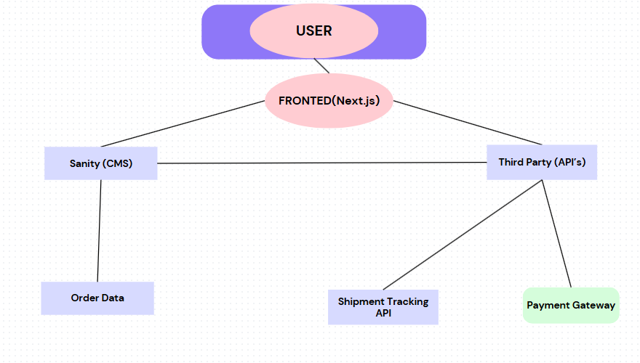

Day 3 API Integration And Data Migration Process :

API Integration: Connecting the frontend and backend with third-party services like payment gateways and shipment tracking to ensure seamless functionality.
Data Migration with Sanity CMS: Moving product and order data into Sanity CMS for structured content management, ensuring scalability and efficient data handling.
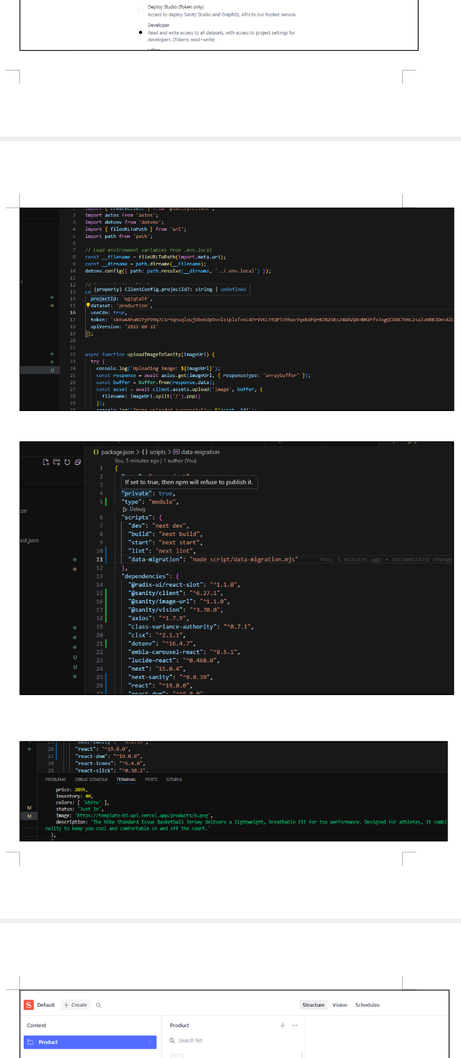

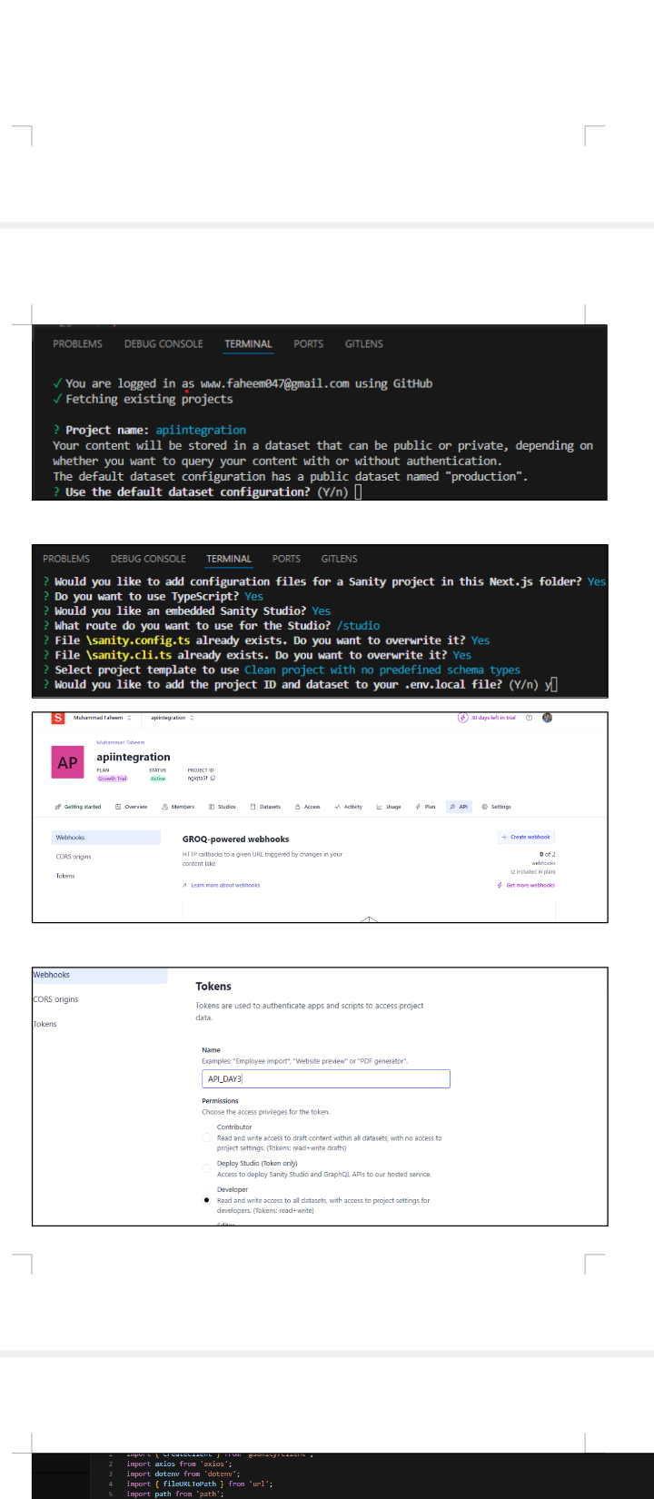

Day 4 Building Dynamic Fronted Components :

Dynamic Routing: Implementing Next.js dynamic routing to enable product and category-based navigation.
Clerk Authentication: Integrating Clerk for user authentication, registration, and secure access control.
Add to Cart Functionality: Allowing users to add products to their cart with quantity adjustments.
Wishlist Feature: Enabling users to save their favorite products for later purchase.
Checkout Process: Implementing a seamless checkout experience with payment and order confirmation.
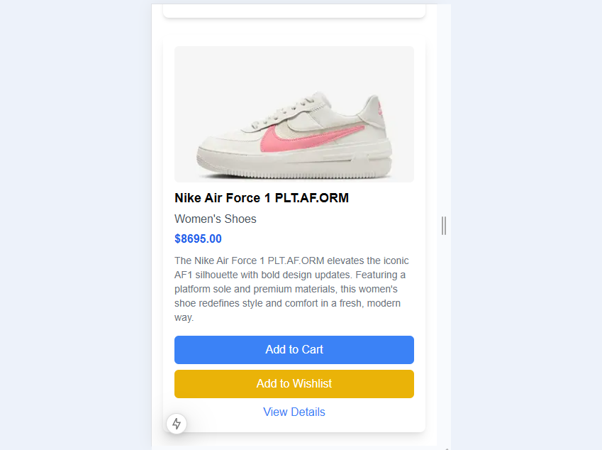

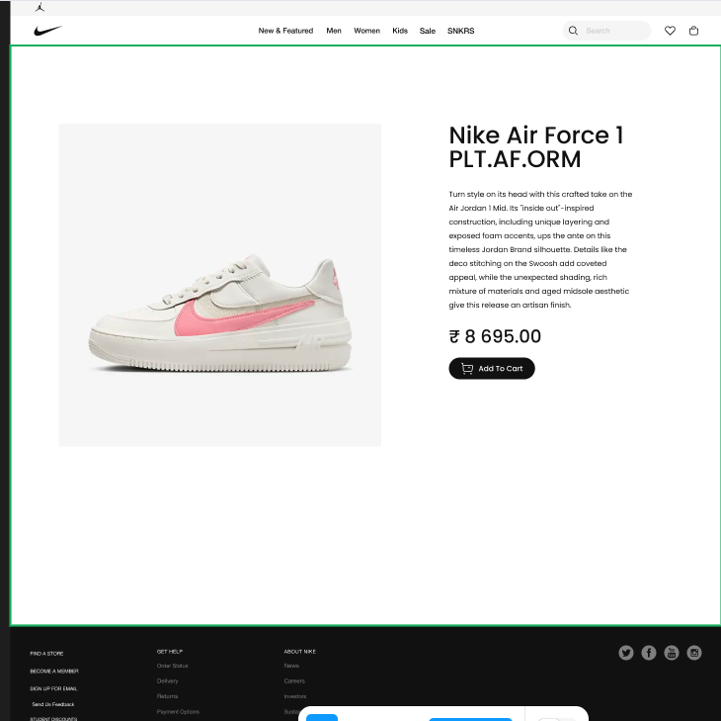

Day 5 Testing Report And Error Handling :
Test Case ID | Test Case Description |  | Test Steps |  | Expected Result |  | Actual Result |  | Status |  | Severity Level |  | Assigned To |  | Remarks
2 |  | TC001 |  | Validate product listing page |  | Open product page > Verify products |  | Products displayed correctly |  | Products displayed correctly |  | Passed |  | Low |  | - |  | No issues found
3 |  | TC002 |  | Test API error handling |  | Disconnect API > Refresh page |  | Show fallback UI with error message |  | Error message shown |  | Passed |  | Medium |  | - |  | Handled gracefully
4 |  | TC003 |  | Check cart functionality |  | Add product to cart > Verify cart contents |  | Cart updates with added product |  | Cart updates as expected |  | Passed |  | High |  | - |  | Works as expected
5 |  | TC004 |  | Ensure responsiveness on mobile |  | Resize browser window > Check layout |  | Layout adjusts properly to screen size |  | Responsive layout working as intended |  | Passed |  | Medium |  | - |  | Test successful

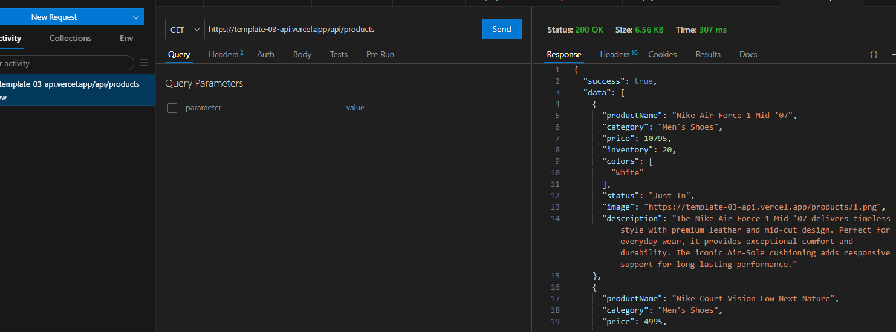

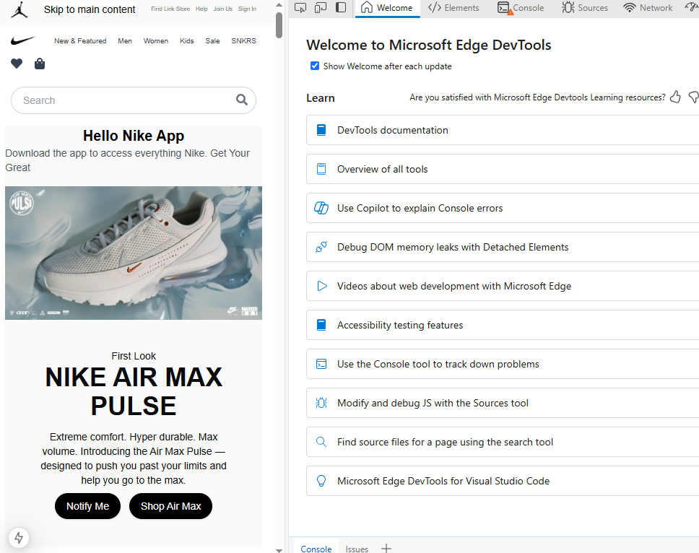

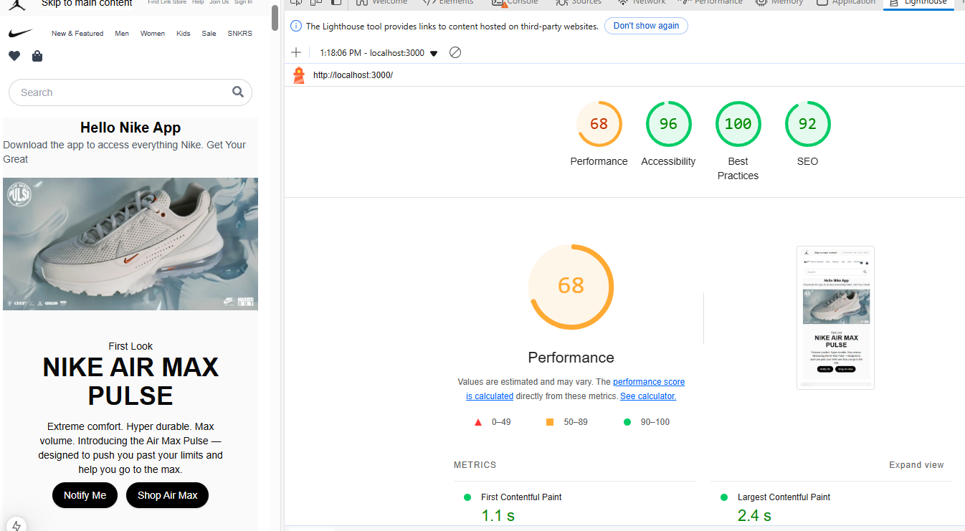

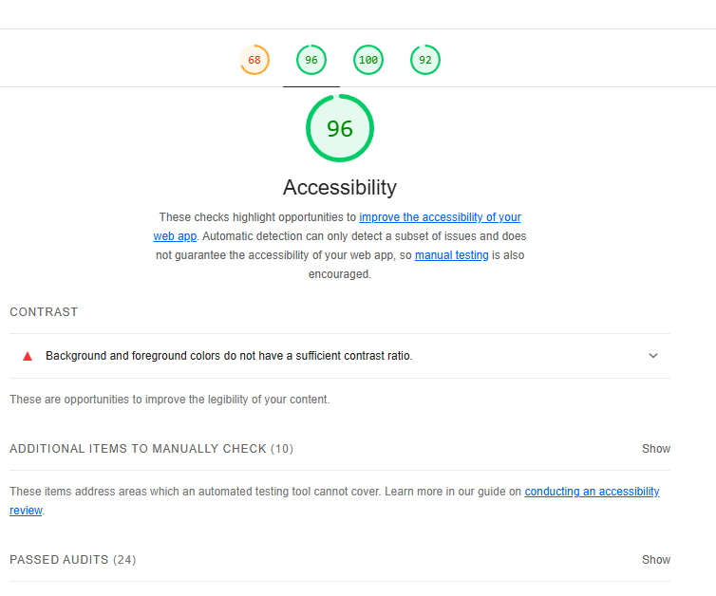

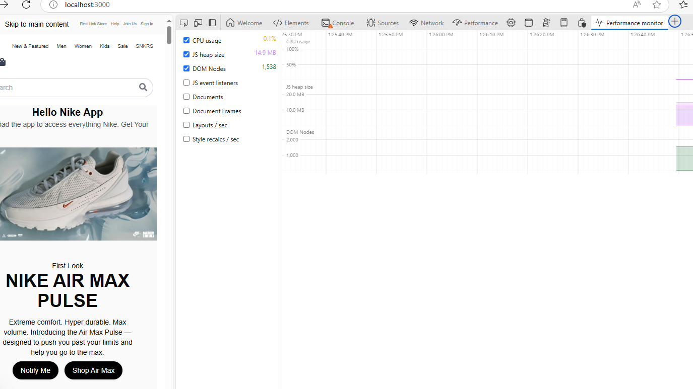

Day 6 Deployment Preparation and Staging :

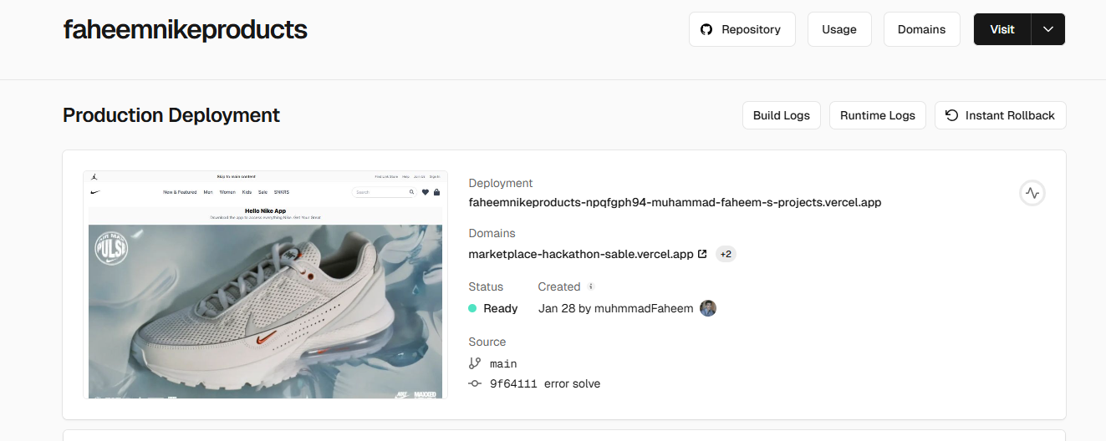

Day 7 Final Day :

Thank You Sir Ameen Alam , Sir Bilal Muhammad Khan and Sir Aneeq Khatri Jazaak Allah Sir!

